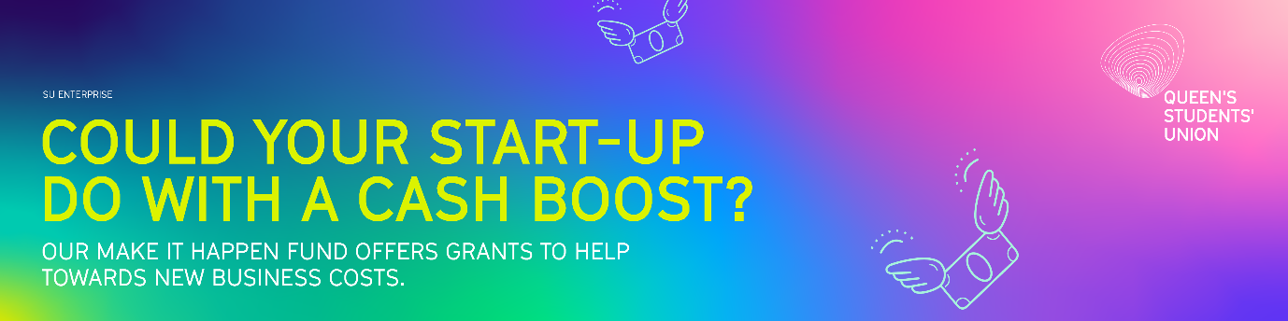

MAKE IT HAPPEN FUND
APPLICATION FORM 2024
The ‘Make it Happen Fund’ is open to all current undergraduate and postgraduate students at Queen’s University Belfast.
Name

Business Name

Student Number

Email Address
Course
Year of graduation
Are you currently on a student VISA?
If yes, please provide details
How you heard about us

Tell us about your business idea
What is it? How does it work? Have you started up? If so, how long have you been trading?

Who will buy your product or service?
Who are your customers? (Business or consumer, demographics etc.)

U.S.P
What is unique about your product or service? (What makes you better than your competitors?)

The Research
What research have you carried out to establish whether this idea is viable? What were your findings from this research?

Support so far
Can you tell us what support you have received so far? (E.g. meetings with SU Enterprise, Go For It Programme etc.)

The Money
Send us a breakdown of what you will need the ‘Make It Happen Fund’ for? Please include quotes for your specific requirements. (Try and make this as accurate and realistic as possible.)

Please send your completed application form to su.enterprise@qub.ac.uk by 31 October 2024 at midday.
Please note that it is not permitted to be registered as self-employed or trade as a business on a Tier 4/Student visa, therefore any funding received through the Make it Happen Fund must only be used for research, planning or prototyping purposes.
If you have any questions about the Terms and Conditions of your Tier 4/Student visa, please visit the Home Office website https://www.gov.uk/student-visa or contact International Student Support at immigration@qub.ac.uk.

